Scope of Work for Chair upholstery/Repair

We will be sending out up to up to (500) Majestic brand gaming chair 7173 style seat meaning it is 18” wide, 17” deep and 4” thick chairs for repair. This is an approximate number. These will not all require repair at the same time and will not necessarily need all units repaired on every chair. The exact material listed below must be used. We would prefer to have a vendor within a 30 miles radius to ensure a quick turnaround time. Price is to be submitted as cost per unit. Deliver is to be priced separately.

Repair Units Possible: Measurements:
- Outer back 24 x 15 with a 64 inch cording
- Inside back 24 x 15 with a 64 inch cording
- Seat 18 x 17 deep and 4 thick
- Seat border 24 x 15 with a 64 inch cording
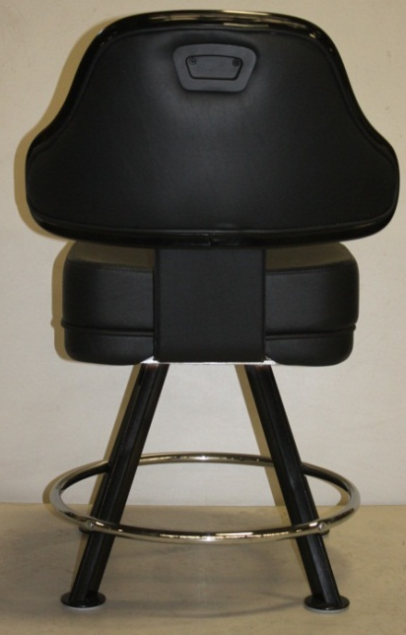

Material Required:
Color - Black
Hi-flex backing
UV Stabilized 500hrs. QUV-B
weatherometer 1500 hrs.
Cold crack -10F
Abrasion 500,000 Double rubs
mildew resistant
antimicrobial/antibacterial
oil and sulfide stain resistant
Requirements:
Installation will not be considered satisfactory until management has conducted an inspection following repairs
Scheduling for repairs whether onsite, pick-up or delivery must be coordinated with facilities management
Supplier must verify with Facilities management point of entry for repair and any requirements for material lay down.
Supplier must notify facility management 24hours in advance of pickup/drop off or onsite repair.
Parts and Supplies provided must be new.
Supplier will be responsible for cleanup of all materials or other debris created from the completions of the repairs

