Statement of Work
Date | 11/22.2023
Client | Cherokee Nation Entertainment (CNE)
Job Name | Hard Rock Hotel Interior Signage
Requested by | Carla Davies
Summary
Hard Rock Hotel is requesting bids for replacement interior hotel door number signage and stairwell signs.

Project Scope
The winning bidder is expected to produce and install hotel door number signs and stairwell signs

Components:

- Contractor Provided
  - 90 - Blue Guestroom number signs
  - 35 – Grey Guestroom number signs
  - 7 – Grey Stairs N signs
  - 7 – Grey Stairs S signs

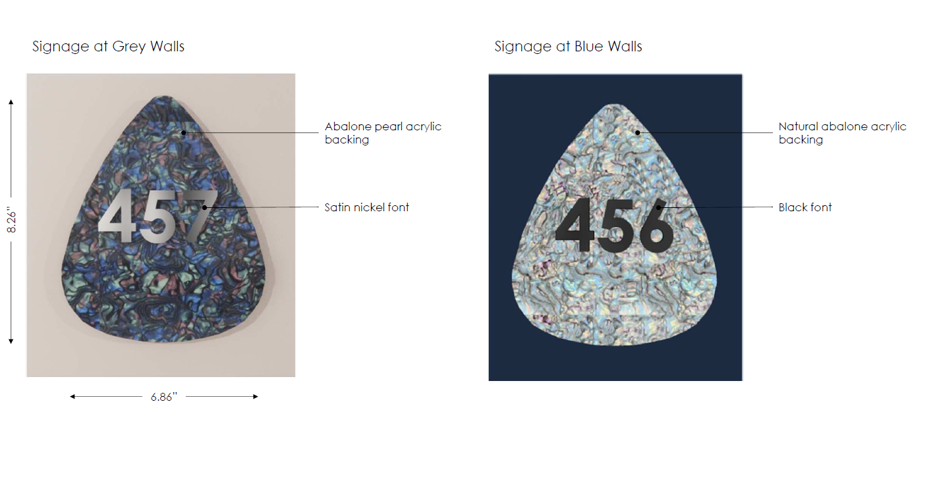

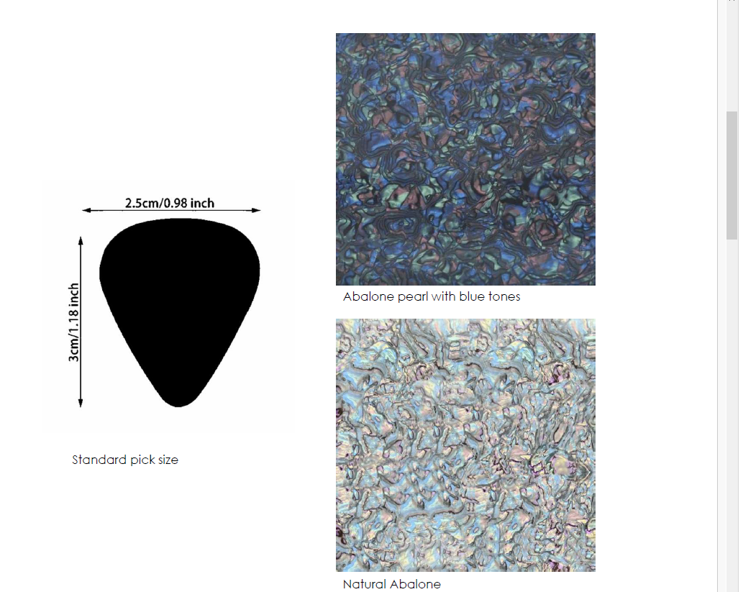

- Miscellaneous – Contractor will provide all miscellaneous components to complete the install.

Tasks:

- Installation – The contractor will install all necessary components to complete the project.
  - Conditions
    - Work schedule will be coordinated with CNE.
    - Contractor is responsible for keeping all work areas clean.
    - Remove old signage if necessary and replace with new.
    - Confirm all neon is functional

