Statement of Work
Date | 11/29.2023
Client | Cherokee Nation Entertainment (CNE)
Job Name | Cherokee Springs sign Replacement
Requested by | Carla Davies
Summary
Cherokee Nation Entertainment is requesting bids for replacement of pylon sign graphics at Cherokee Springs Golf Course.

Project Scope
The winning bidder is expected to produce and install panels for the below double sided sign

Components:

- Contractor Provided
  - Replace plexiglass
  - Wrap with new art

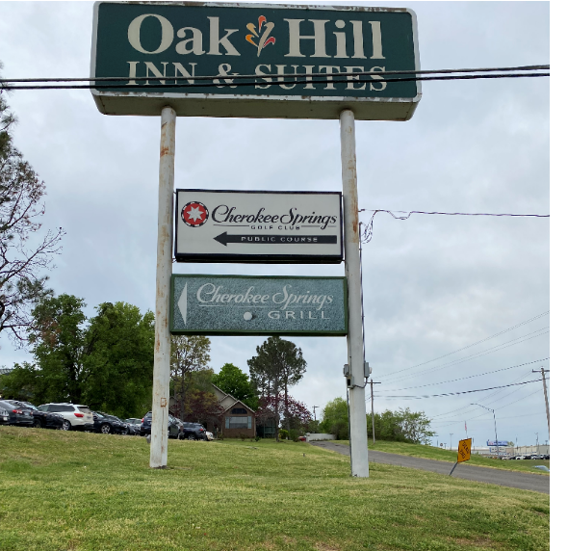

- Miscellaneous – Contractor will provide all miscellaneous components to complete the install.

Tasks:

- Installation – The contractor will install all necessary components to complete the project.
  - Conditions
    - Work schedule will be coordinated with CNE.
    - Contractor is responsible for keeping all work areas clean.
    - Remove old signage.

