

CHEROKEE NATION BUSINESSES, L.L.C. REQUEST FOR PROPOSAL (“RFP”)
PROJECT NAME: CNB/CED IT Service Desk

RFP NUMBER: 151867

DATED: February 12, 2024

TABLE OF CONTENTS

- SOLICITATION TO BID

- INSTRUCTIONS TO BIDDER

- STATEMENT OF WORK

- CONFIDENTIALITY AND BUSINESS RELATIONSHIP/NON- COLLUSION REPRESENTATIONS

- BOND AND INSURANCE REQUIREMENTS
SECTION I

SOLICITATION TO BID CHEROKEE NATION BUSINESSES, L.L.C.

PROJECT NAME: CNB/CED Outsourcing IT Service Desk

Sealed bids are being solicited by Cherokee Nation Businesses, L.L.C. to furnish a proposal for outsourcing CNB/CED IT Service Desk to a qualified service provider. This outsourcing initiative aims to transition the current Service Desk from a shared internal team to a new external provider while maintaining the efficiency, effectiveness, and overall performance of the CNB/CED IT support function.

A Prebid meeting will be held on Friday, February 16, 2024 at 9:30AM CST via TEAMS. Please email stephanie.shults@cnent.com for a link to the meeting.

All proposals shall be submitted to this email address only CNB_CED.ho1i8ioztg2diw1f@u.box.com

Please do not copy the buyer on submittal. If you copy the buyer on submittal, it can be grounds for disqualification.

The bidder must supply all the information required by the RFP Documents, hereinafter defined.

SECTION II INSTRUCTIONS TO BIDDER
  - DEFINITIONS

  - The “RFP Documents” shall mean and shall include the Solicitation to Bid; Instructions to Bidder; Bid Schedule; Statement of Work; Drawings and Specifications, and all other attachments, exhibits and other documents attached hereto and/or incorporated by reference herein.

  - “Company” refers to Cherokee Nation Businesses, L.L.C. soliciting bids and/or proposals for the Work described in the Statement of Work.
  - “Company Representative” refers to the Company personnel who has been designated as the Project Manager as identified in Section I, Solicitation to Bid, or other authorized representative of Company as may be designated in writing.

  - “Contractor” refers to the party acting directly or through agents, subcontractors, or employees and is currently under contract with the Company or upon the award of the bid will enter into a contract directly with the Company.

  - “Subcontractor” refers to the party contracting with the Contractor for any part of the Work as defined in the Statement of Work.
  - “Work” includes all services to be performed or things to be furnished by the Contractor, or both services and things, as the context reasonably requires, including all supervision, labor, materials, supplies, tools, equipment, light, water, fuel, power, heat, transportation, or other facilities necessary for the discharge of all of Contractor’s obligations as described in the Statement of Work.

DESCRIPTION OF WORK

  - The Work to be performed is described in Section III, Statement of Work and Specifications, of the enclosed RFP Documents.

FAMILIARITY WITH RFP DOCUMENTS AND PROPOSED WORK

  - The bidder has the responsibility for examination of all RFP Documents, inspection of all work sites, and familiarization with all conditions concerning the Work. Failure or neglect of the bidder to discharge this responsibility will not excuse nonperformance.

  - The bidder has the responsibility to estimate the time and quantities of work required to complete the Work. Failure or neglect of the bidder to discharge its responsibility will not excuse nonperformance.

  - Company may require prospective bidders to complete a Non-Disclosure Agreement prior to providing the Statement of Work to a prospective bidder.

BIDDING INSTRUCTIONS

  - The bidder shall make its bid by inserting the bidder's figure in the applicable blanks of the Bid Response provided in the Statement of Work, by initialing those inserted figures, by completing any forms, and by returning the completed Bid Schedule to the Company.

  - The bidder must furnish with its bid, a completed and signed Confidentiality and Business Relationship/Non-Collusion Representation, a copy of which is included in the RFP Documents as Section IV.
  - This procurement may be subject to Cherokee Nation Gaming Commission (“CNGC”) policies and procedures. In the event CNGC licensing is applicable, the successful vendor(s) shall be responsible for obtaining all licenses required by CNGC. CNGC licensing requirements may include licensing fees as well as security and background checks of vendor(s) employees. Current policies and procedures can be found on the Cherokee Nation website or by contacting the CNGC office at 918-431-4116.

  - This procurement is subject to Cherokee Nation Tribal Employment Rights Office (“TERO”) regulations that include a fee of ½ of 1% of total contract award and, if applicable, the completion of a TERO Labor Agreement and payment of associated fees. The successful bidder’s award will be published on the Cherokee Nation’s procurement website and their performance will also be measured, recorded, and reported to the
Cherokee Nation. The complete Act is available by contacting the TERO OFFICE at Tahlequah 918-453-5000. TERO bidders are required to provide a copy, front and back, of their TERO certificate with return bid(s) and failure to do so will result in such bidders not receiving the TERO preferences afforded TERO bidders under the CNB procurement and contracting policies and procedures.

  - The bidder must furnish, with its bid, a subcontractor plan indicating what amount of the Contract, either in dollar estimate or percentage of work estimate, will be subcontracted, and the Indian-owned status, if any, of those subcontractors, including tribal identification.

  - All names on the Bid Schedule must be typed or printed below the signature.

  - The Bid Schedule must be completed in ink or by printer. The Bid Price on the Bid Schedule must be stated in words and figures, in case of a conflict words will take precedence. No alterations, additions or erasures shall be made on the Bid Schedule. Erroneous entries shall be lined out, initialed by the bidder and the correct entry inserted.

  - All names on the Bid Schedule must be typed or printed below the signature.

  - The Bid Schedule shall contain an acknowledgment of receipt of all Addenda (the numbers of which shall be filled in on the Bid Schedule).

  - The address to which communications regarding the Bid Schedule are to be directed must be shown.

  - Bids shall be submitted at the time and place indicated in the Solicitation to Bid., marked with the Project Title, Bid Number, Name and Address of the bidder, and accompanied by the other required documents.

QUALIFICATION OF BIDDERS
  - No bid will be accepted unless the bidder can, if requested, show to the satisfaction of the Company evidence of its experience and familiarity with work of the character specified. This may include, at the Company's option, evidence of similar work by its firm (or principal employees) that has been performed satisfactorily and completed during the past five (5) years.
  - No bid will be accepted unless the bidder can show to the satisfaction of the Company evidence of its financial ability to perform the Work successfully and properly, to completion.

  - If bidder has a parent company or relies on a parent company to obtain or fulfill any of the Work to be contracted, then Company has the right to required bidder's parent company to provide guarantee of bidder's proposal and the performance of any obligations arising under a Contract Agreement if bidder has been awarded the bid.
  - If awarded the bid, bidder and any subcontractors of bidder in the performance of the Work shall, to the greatest extent feasible, give preference to Indian organizations, Indian-owned enterprises and individuals as certified by TERO. First preference shall be given to members of the Cherokee Nation and their businesses. Second preference shall be given to members of all other federally recognized tribes.

INTERPRETATIONS

  - All questions about the meaning or intent of the RFP Documents shall be submitted to the Company Representative in writing. Replies will be issued by Addenda mailed to, delivered or sent by facsimile to all parties recorded by Company as having received the RFP Documents. Questions received less than two days prior to the date for opening of bids will not be answered. Only questions answered by formal written Addenda will be binding. Oral and other interpretations or clarifications will be without legal effect.

CONTRACT TIME

  - If applicable as required in the Statement of Work, the number of days within which the Work is to be completed, or the date by which, the Work is to be completed shall be provided as set forth in the Bid Schedule and will be included in the Contract Agreement.

  - If a Project Schedule is required or a Date of Substantial Completion is defined per the Statement of Work, then the Contract Time for the work to be performed shall be considered a material consideration in the award of the bid.

8.00 REJECTION OF BIDS

8.01 Bids received more than ninety-six (96) hours, excluding Saturdays, Sundays and holidays, before the time set for opening of bids, as well as bids received after the time set for opening of bids, will not be considered and will be returned unopened.
Company reserves the right to reject any and all bids when such rejection is in the best interest of Company. All bids are received subject to this stipulation and Company reserves the right to decide which bid shall be deemed lowest and best. A violation of any of the following provisions by the bidder shall be sufficient reason for rejecting his bid, or shall make any Contract between Company and the Contractor that is based on his bid; (i) null and void; divulging the information in said sealed bid to any person, other than those having a financial interest with him in said bid, until after bids have been opened; (ii) submission of a bid which is incomplete, unbalanced, obscure, incorrect, or which has conditional clauses, additions, or irregularities of any kind not in the original Bid Schedule, or which is not in compliance with the Instructions to Bidder and Solicitation to Bid, or which is made in collusion with another bidder. The foregoing list is non-exhaustive and Company reserves the right to reject a bid or nullify any Contract between Company and the Contractor that is based on his bid for any other reason it deems is in the best interest of the Company.

11.00 BIDS TO REMAIN OPEN

All bids and pricing submitted under this RFP shall remain valid and open for sixty (60) days after the day of the bid opening, but Company may, in its sole discretion, release any bid prior to that date.

AWARD OF CONTRACT

  - Company reserves the right to reject any and all bids, to waive any and all bid document requirements and to negotiate Contract terms with the successful bidder, and the right to disregard all nonconforming, nonresponsive or conditional bids. Discrepancies between words and figures will be resolved in favor of words. Discrepancies between the indicated sum of any column of figures and the correct sum thereof will be resolved in favor of the correct sum.

  - Company reserves the right to issue one award, multiple awards, or reject all bids. All quotes are subject to negotiation prior to award. Awards may be issued without discussion of quote received, and quotes should initially be submitted on the most favorable terms from a price and technical standpoint.
  - In evaluating bids, Company shall consider the qualifications of the bidders and whether or not the bids comply with the prescribed requirements.

  - Company may consider the qualifications and experience of subcontractors and other persons and organizations (including those who are to furnish the principal items of material or equipment) proposed for those portions of the Work as to which the identity of subcontractors and other persons and organizations must be submitted. Operating costs, maintenance considerations, performance data and guarantees of materials and equipment may also be considered by Company.
  - Company may conduct such investigations as it deems necessary to assist in the evaluation of any bid and to establish the responsibility, qualifications and financial ability of the bidders, proposed subcontractors and other persons and organizations to perform the Work in accordance with the terms of a Contract Agreement and to Company’s satisfaction within the prescribed time.

  - Company reserves the right to reject the bid of any bidder who does not pass any such evaluation to Company’s satisfaction.

  - A Contract Agreement along with the terms and conditions of such agreement will be negotiated upon award. Company may rescind the award of a bid for failure to agree upon the terms of the Contract Agreement within a reasonable period of time or for bidder’s failure to negotiate in good faith or timely respond to requests or inquiries of Company. Prior to the execution of a Contract Agreement by an authorized representative(s) of each party, the successful bidder shall not perform any services, conduct any business on Company property or acquire or procure any supplies, materials or equipment on behalf of Company to be used in performing the Work as bid, unless specifically requested by an authorized Company Representative in writing. Company will notify the successful bidder in the Statement of Work or Notice of Award that additional executive or board of directors’ approval will be required prior to negotiating the terms of a Contract Agreement. In the performance of the Work awarded, Company, Contractor and its subcontractor(s) shall, to the greatest extent feasible, give preference to Indian organizations, Indian owned enterprises and individuals. First preference shall be given to members of the Cherokee Nation. Second preference shall be given to members of all other federally recognized tribes.

  - The successful bidder shall execute and deliver the Contractor’s Payment and Performance Bond (if required per the Statement of Work or Contract Agreement) and the required certificate(s) of insurance evidencing the limits and endorsements as required by the terms and conditions of the Contract Agreement within five (5) calendar days of receipt of the Notice of Award. If the successful bidder fails to execute and deliver Contractor’s Payment and Performance Bond and the required certificates of insurance(s) within five (5) calendar days of the Notice of Award, Company may annul the Notice of Award.

13.00 BEGINNING WORK
The Work shall be commenced as agreed upon by the parties. However, Work shall not be commenced until Contractor has provided the requisite bonds and proofs of insurance required by the Contract Agreement.

RETURNING OF RFP DOCUMENTS

  - Whether a bid is submitted or not, this collection of RFP Documents and any accompanying documents are to be returned intact.
  - The successful bidder will be furnished necessary copies of this book and documents, conforming to the bid accepted by the Company.

16.00 INVOICING REQUIREMENTS

All invoices for the Work submitted by the successful bidder must be coded in accordance with Company policies. The successful bidder will be responsible for meeting with a representative of Company's Accounting Department regarding necessary coding requirements and complying therewith.
SECTION III

STATEMENT OF WORK CHEROKEE NATION BUSINESSES, LLC

Purpose
The purpose of this document is to outline the requirements for outsourcing CNB/CED IT Service Desk to a qualified service provider. This outsourcing initiative aims to transition the current Service Desk from a shared internal team to a new external provider while maintaining the efficiency, effectiveness, and overall performance of the CNB/CED IT support function.

Scope
The scope of this outsourcing project includes the provision of comprehensive IT service desk support to end-users, incident resolution, request fulfillment, and continuous improvement of service delivery. Including on-site executive leader “white glove” support.

Service Provider Requirements

2.1 Portal: Provider will be required to have a ticket management system that is solely for CNB/CED business – this cannot comingle with other businesses.

2.2 Access: Provider will be required to provide CNB/CED IT support team members with access to the ticketing system for additional supporting.

2.3 On Site Support: Provider should present a “boots on the ground” procedure to ensure there is support in-person, as needed.

2.4 Integrations: Provider should be able to support integrations with other systems to ensure full employee life cycle is supported via service desk. Profile for new employees should be auto generated to ensure requests can be submitted in a timely manner of their onboarding.

2.5 Preferred Vendor: It is preferred to have the same vendor supporting Service Desk requirements per this Service Desk RPF and Asset Management per the Asset Management RFP responsibilities for CNB & CED. If the same vendor is not providing both services; they will be required to partner together for ticketing solutions and support, as needed.

2.6 SLA Reporting: Provider should setup weekly meetings to provide SLA reporting data to CNB Project Manager with the ability to support monthly meetings with CNB/CED Leadership.

2.7 Asset Management: Provider will be required to support asset management request tickets and work with the asset management team to work and close any tickets.

2.8 End User Support: Provider will be required to support Conference Room audio and video issues (surface hubs, iPad, macs, desktop printers, dell, tier 1 support for reaching out to additional vendors based on studio/film equipment)

2.9 Best Practices: Provider should recommend how CNB/CED can maintain best practices for service desk approvals, ticketing, and any other areas where improvement can be made.

2.10 Tiered Support: Provider should provide Tier 1, Tier 2, and Tier 3 support for all CNB and CED employees.

2.11 Special Projects: Provider should be able to support additional special projects (with additional statement of work) as needed and planned in reasonable time. Provider to provide predetermined rate of service for these projects in this quote.

2.12 Growth: Provider should be able to expand support as the business grows. Please ensure to provide a quote for pricing based on growth to come.

2.13 Pricing Matrix: Please provide pricing by employee count to ensure there is an FTE cost associated with this process. Please ensure there is a “white glove” cost included.

2.14 Security: Provider must adhere to security requirements of CNB. Please confirm how users are authenticated for support assistance.

2.15 Location: Provider must be US Based, with no support provided by offshore resources.

2.16 Software: Any software or application not currently in use will require CNB CISO approval to be included for any CNB/CED user.

2.17 Pricing: Provider should include pricing for licensing and service requirements in order to support CNB/CED.

2.18 Right of Removal: CNB has the right to remove an employee from the account at any time.

2.19 Standard Operating Procedure: Provider should provide their Standard Operating Procedures for supporting end users through their full life cycle of Service Desk needs.
  - Expertise and Experience
The selected service provider must demonstrate:
    - Proven experience in providing IT service desk support, preferably for organizations of similar size and complexity, including white-glove support.
    - Technical expertise across a broad range of IT systems and applications.
    - A track record of meeting or exceeding service level agreements.
    - Ability to support application deployment & patch management support through service desk in coordination with asset management support.

Service Offerings
The service provider should offer:
    - Incident management and resolution.
    - Request fulfillment.
    - Knowledge management.
    - Continuous service improvement initiatives.
    - Participate in Cyber Incident Response Team (CIRT) & Cyber Incident Response Plans (CIRP) initiatives.
    - Provide Tier 1, Tier 2 & Tier 3 support, 24x7.
    - ITSM tool capable of tracking the previously listed items with access to CNB/CED employees
    - 24x7 Executive “White Glove” Support, onsite during meetings and on-call during traveling
      - Audio and Video support & on-site support

Scalability
The service provider must be capable of scaling services to accommodate our growing business needs.

Security and Compliance
The service provider must adhere to:
    - Strict security measures to safeguard sensitive information.
    - Compliance with relevant data protection and privacy regulations.

Reporting and Metrics
The service provider should provide:
    - Regular performance reports, including key performance indicators (KPIs) and service level achievements.
    - A mechanism for continuous improvement based on performance metrics.

Transition Plan
Steps and timelines for transitioning the IT service desk from the current in-house model to the outsourced model. Include:
- Knowledge transfer processes.
- Staffing requirements during the transition.
- Communication plans for end-users and internal staff.

Service Level Agreements (SLAs)
- Hours of support: 24 hours a day, 7 days a week, including holidays
- Call Volume – 250 average interactions monthly
- CED/CNB staff to be supported across 31 locations
  - 450-500 Team Members
  - 31 Locations
- Executive White Glove Support – 24x7 for 40 executives and board members
- Standard Target Service Desk SLAs for executives is same day
- Escalation Procedures – in the event a ticket not being closed within SLA, provider should reach out to leadership within CNB immediately with a plan to close the ticket and timing.

Standard Target Service Desk SLAs
Services | Detail | SLA | Target | Attainment
Response | Phone | Average Speed to Answer | 60 seconds or less | 98%
Response |  | Average Abandon Rate | 6% or less after 60 seconds | 98%
Response | Email | Conversion of non- phone-based incidents generated from e-mail or self- service portal | Less than 60 minutes during Business Hours* | 98%
Resolution | First Call Resolution | FCR on eligible calls | 98% | 98%
Customer Satisfaction | Survey | Survey | 85% | 98%
EXECUTIVE Target Service Desk SLAs
Services | Detail | SLA | Target | Attainment
Response | Phone | Average Speed to Answer | 60 seconds or less | 100%
Response | Email | Conversion of non- phone-based incidents generated from e-mail or self- service portal | Less than 15 minutes | 100%
Resolution |  | 2 Hours | 95% | 98%

Contractual Agreements
Define the terms and conditions of the outsourcing agreement, including:
- Contract duration.
- Service costs and payment terms.
- Termination clauses.
- Confidentiality agreements.

Governance and Communication
Establish a governance structure that includes:
- Regular review meetings.
- Escalation procedures for issue resolution.
- Communication plans for both day-to-day operations and exceptional circumstances.

Proposal Submission
Service providers should submit proposals addressing each requirement outlined in this document. Proposals should include:
- Company background and experience.
- Service offerings and capabilities.
- Pricing details.
- References from current or past clients.

Timeline
- Release of Request for Proposals (RFP): Feb 12th 24
- Proposal Submission Deadline: Feb 23rd 2024
- Vendor Selection: Mar 1st 24
- Transition Initiation: Mar 11th 24

Appendix

- Incident Tickets opened last 12 months – averaging 50/month
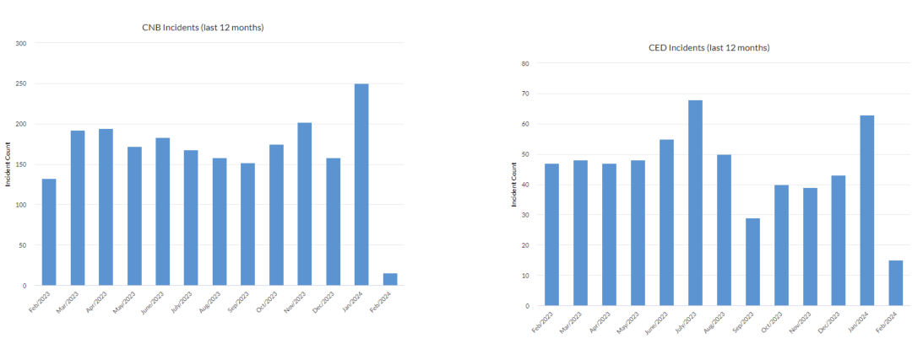
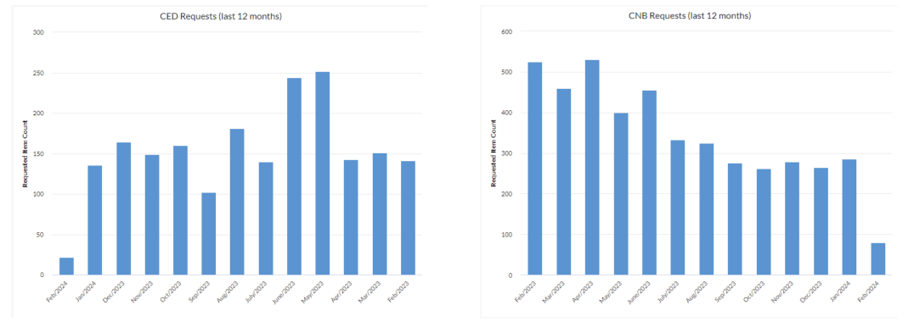
- Request Tickets opened in last 12 months – averaging 300/month
- Board members are based out of their homes, it is expected that support is provided to them directly, when needed.
- Enterprise Application support will not be required, tickets will need to be passed to internal resources for these items.
- Executive Team members are based out of their homes, Corporate Woods, Marshall, and Downtown Tulsa and will require hand-on support “boots on the ground”, as needed, 24x7
- Executive Team members also travel and will need white-glove support while traveling.
- Executive Team and Board Members will not open a ticket, the provider will be required to open the ticket on their behalf and see it through closure.
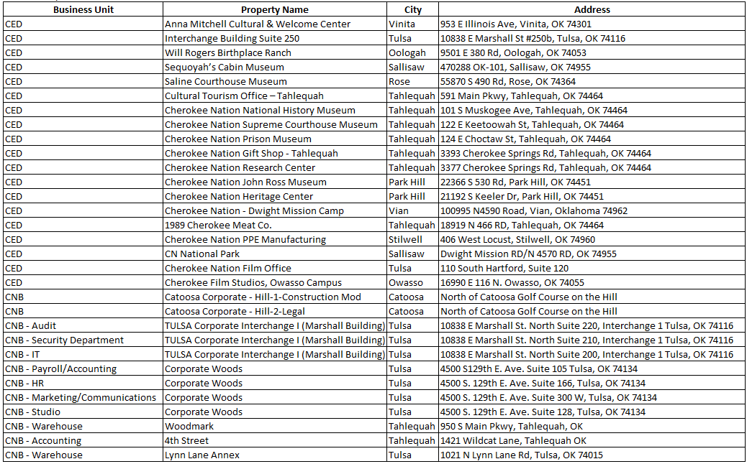
- 450 team members are located across the following locations where support will be required:

SECTION IV

CONFIDENTIALITY AND BUSINESS RELATIONSHIP/NON-COLLUSION REPRESENTATIONS

In connection with discussions and/or negotiations between the responding entity (“Bidder”) and the applicable Cherokee Nation entity (“Company”) (individually “Party” or collectively “Parties”) regarding
PROJECT NAME: CNB/CED Outsourcing IT Service Desk

RFP NUMBER:151867
Each Party agrees that any written information, drawings or data disclosed by the other Party as well as all information becoming known to either Party concerning the other Party’s inventions, discoveries, improvements, methods, business plans, ventures, practices, enterprises, or operation, or any other information affecting the business operations of the other Party shall be deemed to be confidential and proprietary information owned by such Party, and shall be protected by the receiving Party in the same manner and with the same degree of care the receiving Party treats its own confidential or proprietary information (“Confidential Information”). The receiving Party agrees to and shall be fully responsible for all Confidential Information of the disclosing Party in the receiving Party's possession and the receiving Party shall promptly upon demand, return all such Confidential Information and reproductions therefrom to the disclosing Party or destroy the Confidential Information and certify such destruction to the disclosing Party. If either Party loses or makes an unauthorized disclosure of the other Party's Confidential Information, it shall notify such other Party immediately and use reasonable efforts to retrieve the lost or wrongfully disclosed Confidential Information.
Confidential Information shall not be disclosed, except to the extent required by law, to any third person or entity without the prior written consent of the disclosing Party other than to those directors, officers, employees, affiliates, agents or consultants with a need to know the Confidential Information in connection with the project referenced above. Except as permitted in the previous sentence, prior to disclosure to any such third person or entity, such third person or entity must have agreed in writing to treat the Confidential Information as confidential in the same manner as required of the receiving Party. The Parties shall use the Confidential Information only in connection with continuing discussions by the Parties concerning the Project, except as may otherwise be mutually agreed upon in writing.
Confidential Information shall be treated in the manner specified above until such time as such Confidential Information: (i) is otherwise available in the public domain; (ii) is established to have been lawfully known by the receiving Party prior to receipt of such Confidential Information from the disclosing Party or becomes known by the receiving Party through a third party not subject to the non-disclosure requirements of this Agreement; (iii) is developed by or on behalf of the receiving Party independent of any Confidential Information furnished by the disclosing Party under this Agreement or (iv) is required to be released by a valid law, regulation or court order, and sufficient notice is given by the receiving Party to the disclosing Party of any such
requirement or request to permit the disclosing Party to seek an appropriate protective order or exemption from such requirement or request.
The receiving Party acknowledges that in the event of an unauthorized disclosure, the damages incurred by the disclosing Party may be difficult if not impossible to ascertain, and that the Disclosing Party may seek injunctive relief as well as monetary damages from the receiving Party. Neither the disclosure of Confidential Information, nor the ongoing discussions and correspondence between the receiving Party and the disclosing Party, shall constitute or imply a commitment or binding obligation between the parties or their respective affiliated companies.
Neither Party shall be: (a) responsible or liable for any business decisions made or inferences drawn by the other Party in reliance on this Agreement or in reliance on actions taken or disclosures made pursuant to this Agreement; or (b) liable to or through the other Party for amounts representing loss of profits, loss of business, or special, indirect, consequential, or punitive damages.

This Agreement shall be binding upon Company with regard to the Project as if executed by Company and shall become effective upon signature by Bidder (“Effective Date”). The Agreement shall continue in force until terminated by either Party, notice is provided by Company that Bidder was not the winning bidder, or until superseded by a subsequent non-disclosure or definitive agreement containing confidentiality provisions. The obligations of the parties shall survive and continue beyond the expiration or termination of the Agreement for a period of two (2) years with regard to Confidential Information.
NOTWITHSTANDING ANYTHING IN THIS AGREEMENT TO THE CONTRARY OR PRESENTED IN THE BID PROPOSAL DOCUMENTATION, NEITHER PARTY MAKES ANY REPRESENTATIONS OR WARRANTIES OF ANY NATURE WHATSOEVER WITH RESPECT TO ANY INFORMATION DISCLOSED, INCLUDING, WITHOUT LIMITATION, ANY WARRANTIES OF MERCHANTABILITY OR FITNESS FOR A PARTICULAR PURPOSE OR AGAINST INFRINGEMENT.
The Parties acknowledge that this Agreement does not restrict the ability either to engage in their respective businesses nor does it limit either Party's use or application of any information or knowledge acquired independently of the other without a breach of this Agreement in the course of such Party's business.
The Parties agree that this document may be electronically signed and that signatures appearing on this document are the same as handwritten signatures for the purposes of validity, enforceability, and admissibility.

SIGNED: TITLE: DATE:

CONFIDENTIALITY AND BUSINESS RELATIONSHIP/NON-COLLUSION REPRESENTATIONS

, on behalf of (Bidder name) represents and warrants that the nature of any partnership, joint venture, or other business relationship presently in effect or which existed within one (1) year prior to the date of this statement with Company or other party to the services provided under the Agreement is as follows:

, on behalf of (Bidder name) represents and warrants that any such business relationship presently in effect or which existed within one (1) year prior to the date of this statement between any officer or director of Consultant and any officer, director, manager or member of the Board of Directors of Company or other party to the project is as follows:

, on behalf of (Bidder name) represents and warrants that the names of all persons having any such business relationships and the positions they hold with their respective companies or firms are as follows:

, on behalf of (Bidder name) represents and warrants that any family/relative relationships present between any officer, director or agent of Bidder and any officer, director, manager or member of the Board of Directors of Company other party to the Agreement is as follows:

, on behalf of (Bidder name) represents and warrants states that the names of all persons having any such family/relative relationships and the positions they hold with their respective companies or firms are as follows:

If none of the business relationships hereinabove mentioned exist, Representative should so state below

SIGNED: TITLE: DATE:

CONFIDENTIALITY AND BUSINESS RELATIONSHIP/NON-COLLUSION REPRESENTATIONS

, on behalf of (Bidder name) represents and warrants that (s)he is the agent authorized by the bidder to submit the attached bid. Representative further states that the bidder has not been a party to any collusion among bidders in restraint of freedom of competition by agreement to bid at a fixed price or to refrain from bidding; or with any employee of Company or any affiliate or wholly-owned entity of Company as to quantity, quality or price in the prospective definitive Agreement, or any other terms of said prospective definitive Agreement; or in any discussions between bidders and any official of Company or any affiliate or wholly-owned entity of Company concerning the exchange of money or other things of value for special consideration in the letting of a definitive Agreement.

SIGNED: TITLE: DATE:

SECTION V

BOND AND INSURANCE REQUIREMENTS
Minimum Insurance for Bidding: Bidder shall provide with its bid, certificates of insurance on an ACORD 25 or 25S form evidencing all available coverages, however, to be considered an acceptable bid the following minimum coverages and limits and any additional insurance requirements specified in the Statement of Work must be evidence on the submitted certificates of insurance. The limits set forth below are minimum limits. Additional limits or policies may be required per the terms and conditions of the Contract Agreement.

- Worker's Compensation insurance complying with the laws of the State or States having jurisdiction over each employee, whether or not Contractor is required by such laws to maintain such insurance, and Employer's Liability with limits of $500,000 each accident, $500,000 disease each employee, and $500,000 disease policy limit.

- Commercial or Comprehensive General Liability insurance on an occurrence form with a combined single limit of $1,000,000 each occurrence, and annual aggregates of $2,000,000, for bodily injury and property damage, including coverage for blanket contractual liability, broad form property damage, personal injury liability, independent contractors, products/completed operations, and when applicable the explosion, collapse and underground exclusion will be deleted.
- Automobile Liability insurance with a combined single limit of $1,000,000 each occurrence for bodily injury and property damage to include coverage for all owned, non-owned, and hired vehicles. In each of the above described policies, Contractor agrees to waive and will require its insurers to waive any rights of subrogation or recovery they may have against Company its parent, subsidiary, or affiliated companies.

- Pollution Liability insurance in the amount of $1,000,000 each incident and annual aggregate of
$2,000,000 (only applicable for bidding if required per the Statement of Work). Upon award of the bid Company may require this coverage per the Contract Agreement if such coverage is merited per the scope of the Work to be performed and the minimum limits quoted may be adjusted accordingly.

- Professional Liability insurance with limits of not less than $2,000,000 for each claim and an annual aggregate of not less than $2,000,000 (only applicable for bidding if required per the Statement of Work). Upon award of the bid Company may require this coverage per the applicable Contract Agreement or Service Agreement if such coverage is merited per the scope of the Work to be performed. The limits for professional liability insurance may be adjusted depending on complexity and size of the project and the scope of services to be provided. Any adjustments to these limits will be identified in the applicable terms and conditions of the Contract Agreement or Service Agreement.
Additional Insurance Requirements upon Award of Bid:

- At a minimum the following will be required for Commercial or Comprehensive General Liability and Automobile Liability policies (Company may identify additional policies that are subject to this requirement and such additional policies and requirements will be made a part of the terms and conditions of the Contract Agreement):
  - Company its parent, subsidiary and affiliated companies will be named as additional insured.
  - The policies shall include the following “other insurance” amendment: “This insurance is primary insurance with respect to Company its parent, subsidiary and affiliated companies, and any other insurance maintained by Company its parent, subsidiary or affiliated companies is excess and not contributory with this insurance.”
Waiver of Subrogation: In each of the policies required per the Contract Agreement, bidder agrees to waive and will require its insurers to waive any rights of subrogation or recovery they may have against Company, its parent, subsidiary, or affiliated companies.

At least five (5) days prior to the commencement of the Work, Contractor shall deliver to Company certificates of insurance on an ACORD 25 or 25S form evidencing the existence of the insurance coverage required per the Contract Agreement. In the event coverage is denied or reimbursement of a properly presented claim is disputed by the carrier for insurance provided in subsections (A) through (E) above, Contractor shall, upon written request, provide Company with a certified copy of the involved insurance policy or policies within ten (10) business days of receipt of such request.

Bid Bond and Performance, Payment and Maintenance Bonds:

- Bid Bond. If required per the Statement of Work, a Bid Bond may be required as proof of the bidder’s ability to bond the Work. If awarded the Work, Performance, Payment and Maintenance Bonds may be required as indicated below.

- Performance and Payment Bond. If required per the Statement of Work or Contract Agreement, the successful bidder shall obtain and provide to Company a Payment and Performance bond covering discharge of the successful bidder’s obligations. This insurance guarantee shall represent one hundred percent (100%) of the total contract award (including any and all subsequent additions and deletions to the contract award due to changes in the scope of the work). Said bond shall be issued in a form acceptable to Company covering the obligations of the successful bidder under the Contract Agreement. Company may, at its election, terminate the Contract Agreement if the required bond is not obtained within such time as Company will deem reasonable (in no event later than commencement of the Work). This insurance guarantee shall remain in full force until final acceptance of successful bidder’s work.

Any increase in the Contract amount shall automatically result in a corresponding increase in the Bond's penal amount without notice to or consent from Surety, such notice and consent being hereby waived. Decreases in the Contract amount shall not, however, reduce the Bond's penal amount unless specifically provided in said Change Order.

The Surety hereby waives notice of any change, including changes of time, to the Construction Contract or to related subcontracts, purchase orders, and other obligations.

- Maintenance Bond. If required per the Statement of Work or Contract Agreement, the successful bidder may be required to obtain and provide to Company a Maintenance Bond guaranteeing Company, that the bidder will solve all maintenance issues during the specified maintenance period, which is usually one (1) year from final acceptance of successful bidder’s work. The maintenance period could be longer depending upon the terms of the Contract Agreement.
Additional bonding requirements may be identified by Company in the Statement of Work or Contract Agreement.

