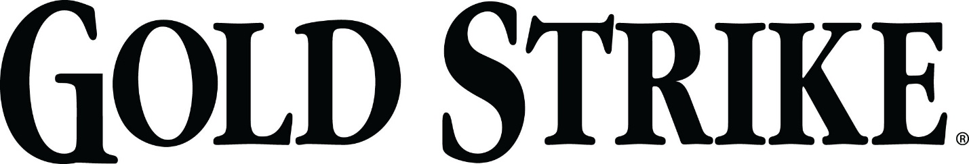
RFP – GS – PAPER PRODUCTS
BID # 151944

QUESTIONS AND ANSWERS

Q. What products are you currently utilizing, and can you share Pricing?
A. Currently we are using KC branded products:
Toilet Tissue – KCC13217
Roll Towels – KCC02000
Roll Towel 2 – GPC89460
Multifold – KCC01804
Facial Tissue – KCC21320
**I cannot share current pricing on products. Please refer to Statement of Work for usages**

Q. Does a Dispenser option need to be bid or can just the paper item be bid? (ie. Household Rolls)
A. Dispenser options are not necessary on household roll tissue, as it is my assumption that Household rolls fit most Household dispensers. HOWEVER, Jumbo Roll Tissue will need an option, as we currently do not have JRT installed. Roll Paper Towels will need to have an option, unless they fit our current dispenser.

Q. Is there a Bid Bond or Bid Security required for this bid or upon award?
A. No Bid Bonds or Securities are needed on this Project.

Q. Are you looking for products that fit your current Dispensers or a manufacturer with proprietary Dispensers?
A. No, we are looking more for an economical brand of paper for this project. More house brand items

Q. In the Bid Documents, it states “Any award resulting from this RFP will be subject to CNE Terms and Conditions (copy available upon request).
A. Standard Terms and Conditions are posted under “Documents” on the bid site.

Q. What are the Industry Standards or Regulations on the products bid?
A. The specs listed in the RFP Scope are our minimum standards, no other standards need to be met. As for regulations – as long as they follow whatever regulations the manufacturers are held to or governed by, is satisfactory.

Q. What are the policies and procedures and licensing requirements of regulatory authorities that apply to this RFP?
A. No Regulations or Gaming Licenses are needed for this RFP.

