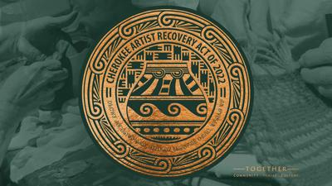

Call for Art – Cherokee Artist Recovery Act
Original 2D and 3D art
Multiple Properties Throughout Cherokee Nation

Summary
The COVID-19 pandemic has had a significant impact on the livelihoods of Cherokee artists. The temporary closure of art galleries and the cancellation of art shows and exhibitions have severely affected their income.
To help Cherokee artists, rebound culturally and economically, the Cherokee Artist Recovery Act includes funds for the acquisition of Cherokee art. In accordance with this act, Cherokee Nation Businesses (CNB) is accepting bids for original art to display within several locations throughout the Cherokee Nation reservation including, but not limited to, Cherokee Nation properties, Cherokee Nation Businesses properties, and Cherokee Nation Entertainment properties.
CNB only accepts bids from Cherokee Nation citizens who can provide identification and artists previously designated as Cherokee National Treasures.

All artwork selected will receive a label to accompany its future display and will include the Artist Recovery Act insignia and supplemental text “Property of Cherokee Nation- Acquisition made possible by the Cherokee Artist Recovery Act of 2022.”

Description
Artists are encouraged to submit artwork related to Cherokee history, culture, and heritage. Artwork that includes cultural or historical elements, including but not limited to historic figures, clothing, language, and symbolism should be historically and culturally accurate. Artists are also encouraged to submit artwork in contemporary styles and mediums.

Submissions will be reviewed for selection by a committee.

Example themes may include, but are not limited to the following:
- Cherokee traditional stories
- Animals and plants important to Cherokee history and culture
- Depictions of the seven clans
- Depictions of Cherokees throughout history – from time immemorial to present day
- Traditional cultural practices such as stickball, stomp dance, etc.
- Traditional southeastern symbolism
- Cherokee language
- Interactions between multiple generations
- Contemporary themes

REQUIREMENTS
- Artists’ submissions should include image of artwork, dimensions, medium, and price. A form will be provided for digital submissions.
- Artists are allowed to submit a maximum of 20 pieces.
- Artists that submit their work with syllabary will be subject to having our translation team review for accuracy.
- Artists’ work will be subject to a review of cultural authenticity.
- It is the artist responsibility to mail or deliver the art if selected.
- We will only accept completed works of art.

Proof of Citizenship
Cherokee Nation law requires the purchase of art from Cherokee Nation citizens only. You must submit a copy of your Blue Card or Citizenship Card when submitting an initial proposal. No exceptions.

Bid submission:
Bids will be accepted digitally. Deadline for this bid is May 16, 2024, at 5pm.

Bid information for digital submissions:
Bids can be submitted digitally to CED Senior Buyer, Amy Eubanks at amy.eubanks@cn-bus.com. If you have any questions, please contact Amy Eubanks via email or at (918) 422-6593.

- Digital bids must include the following:
  - Title
  - Price
  - Description of the work
  - Medium
  - Dimensions
  - Art form filled out for each piece submitted.
  - Citizenship card copy

