Statement of Work

|  |  |
| --- | --- |
| Date | 7/25/2024 |
| Client | Cherokee Nation Entertainment (CNE) |
| Job Name | Machine Entry Authorization Log (Meal Books) |
| Requested by | Trinity July |
|  |  |

Summary

Cherokee Nation Entertainment is requesting bids for 9,760 Machine Entry Authorization Logs. **Must be licensed through the Cherokee Nation Gaming Commission CNGC and the Oklahoma Horse Racing Commission OHRC.** Books will be printed double-sided, 1 color with 92 pages including the cover. Books must be scored, folded, collated and saddle stitched.

Project Scope



The winning bidder is expected to provide

**Components:**

1. **Vendor Provided**

**9,760 complete meal books with the below specifications.**

Key Requirements

* Gaming Meal Books
* 5.5” X 8.5”
* 92 pages including cover
* Cover : 80# white gloss
* Inside: 50# offset white
* Score cover – fold – collate – saddle stitch
* Prints double sided – 1 color black
* See attached pictures
* Packaged in 122 cartons of 80 each.

**Statement of Deliverables**

Please provide shipping costs and lead time for delivery to the below location:

777 W. Cherokee St.

Hard Rock Hotel & Casino

Catoosa, OK 74015

**Examples**

**Front Cover**

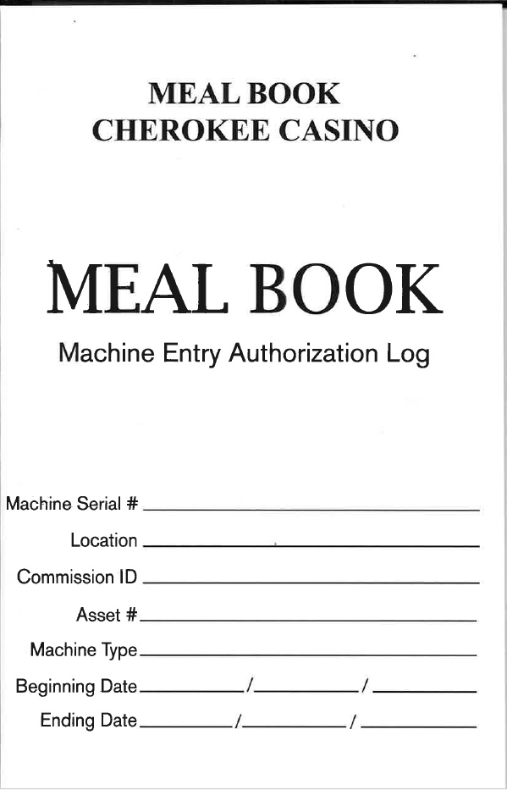

Inside

