### CHEROKEE NATION SPEAKERS SERVICES

O FFICE: 918 .207 .4904

## Home Rehabilitation/Replacement Site Directions

Name: _ Donald Lee Sevenstar _ Telephone: none _

Address: _ 474106 E 1007 RD _

_Muldrow, OK 74948 _

County: _Sequoyah _ Year Built: 60's---

GPS Coordinates: 35.4804575,-94.665254 _

* Drive Directions: From Muldrow OK

### Head North on OK-64B 10.5 miles

* Turn right onto OK-101 East 2.1 miles
* Turn right onto E 1007 RD
* Destination on Right 350 ft small white house

Cost Estimator/ Inspector _Lonnie Ragland

_ Date:

7/24/25

*WorkWrite-Up and Bid Document/By Area*

### Donald Lee Sevenstar

#### 474106 E 1007 Rd Muldrow, OK 7-4948

*Contractor Name:*

*Contractor Signature:*

(000) 000-0000 *Tllil' document mw,t he .\ignetl to he" Vlllid bid.*

***PROJECT TYPE:* Rehabilitation Bid Due Date:**

***Area Work Description*** *I* ***Comments Gen. Spec.*** *Qty Unit* ***Item Bid***

Drywall/Ceiling/Install new 5/8" drywall on ceiling/Finish completely. Work shall include tape, bed and texture to match existing surfaces.

|  |  |  |  |  |  |
| --- | --- | --- | --- | --- | --- |
| **EXTERIOR** |  | | | | |
| **1**  Soffit/Repair. Repair damaged soffit/See comments. | *Div.* # 6 . P | SOSF I I | | | |
| replace any and all rotted or damaged soffits and paint to match 2 coats |  |  |  |  |  |
| **INTERIOR** |  |  |  |  |  |
| **2** | *Div.* # 9.D |  |  |  |  |

150SF I I

repair and or replace leak damaged drywall a-nd-pa-int -2 c-oa-ts -------------------

**ROOF**

**3** *Div.* **# 6 .P**

Fascia/Replace/1" x 4". Replace Fascia/1" **x 4".**

replace rotted fascia paint to match

50LF I I

***Print Date: Thursday, July 24, 2025*** *474106 E 1007 Rd Muldrow, OK 7•4948 Page 1 of 3*

***Area*** *Work Description I :c omments*I ***Gen.*** *Spec. Qty Unit* ***Item Bid***

**ROOF**

**4** *Div.* # 7.F. 220LF

Flashing/Drip Edge/Replace. Replace drip edge flashing. Match existing as closely as possible.

approx 220 ft drip edge replacement -

|  |  |  |
| --- | --- | --- |
| **5** | *Div.* # 7 . F |  |
| Flashing/Replace. Replace flashing.  replace needed flashing |  |  |
| **6** | *Div.* # 7 .A. |  |

I I

Roofing/Architectural/30 Year Warranty. Install fiberglass shingles/Minimum 30 year warranty/Use Owens Corning "Classic" or written approved equal. Remove all shingles, felt, pipe jacks and flashing.

install shingles, starter appro x. 80If . install ndge approx 951f , install felt 20sq, install ice and

water shield, replace required decking haul off and dispose of debris -

40LF I I

20Sq I I

1. *Div.* # 7 .C 20Sq

I I

Roofing/Strip/Built-Up. Strip roof/built-up.

tear off old roofing and rotted sheeting  ~~-~~

I I

1. *Div. ff 7 .A* 200SF

Sheathing/3/4" COX/Replace. Replace existing sheathing/Use 3/4" CDX. replace up to 200 sf of sheeting

***Print Date: Thursday, July 14, 1025 .f7'106 E 1007 Rd Muldrow, OK 7-.f9.f8 Page2of3***

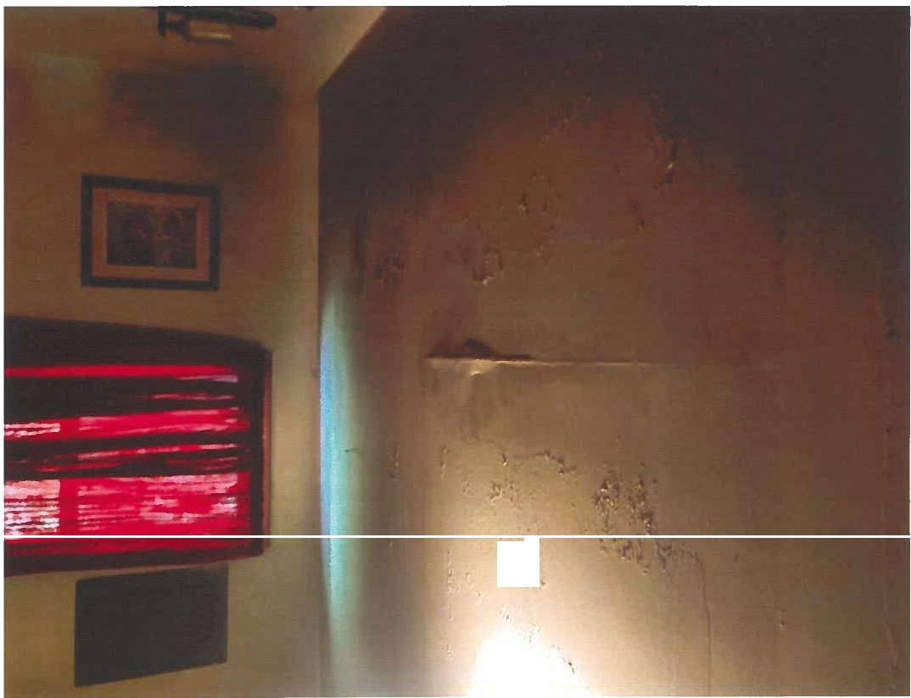

*"P;* r

# •

• • •

'

,

""

