I have a question to about your bid for bid for Multiple Exhaust Fans with Procurement #163808, for VSBB item # 1. There are some variables on these fans. VSBB is the base model. That is highlighted in your Exhibit A attachment in page # 1, Can you please provide the additional information, like the CFM, Power being used, size required, and SP see the picture below:

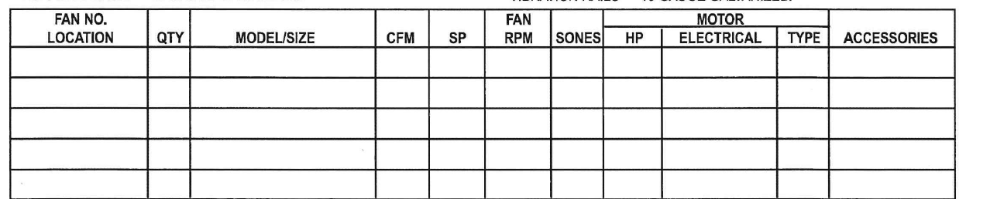

Please let me know for me, to quote this item # 1 correct.

Bidder was referred to document on next page:

