Cigarette Vending Machine Specs
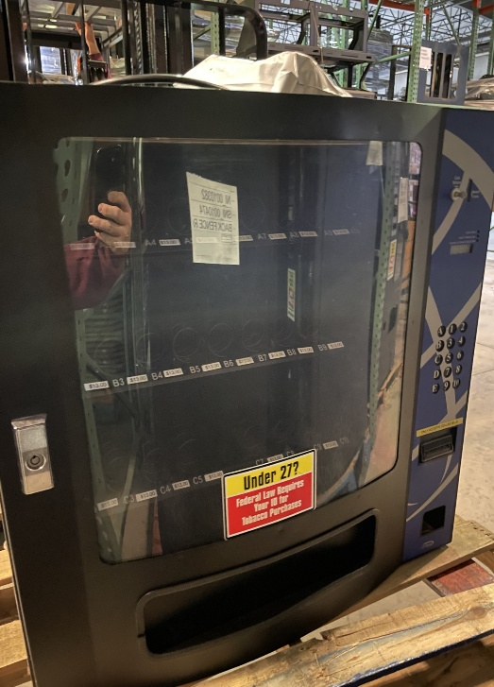
- Model # VC630S
- Ser # VC6S041401009
- 32” Wide X 25” Deep X 31” Tall
- Price for Sell: 1550.00
- QTY: 1

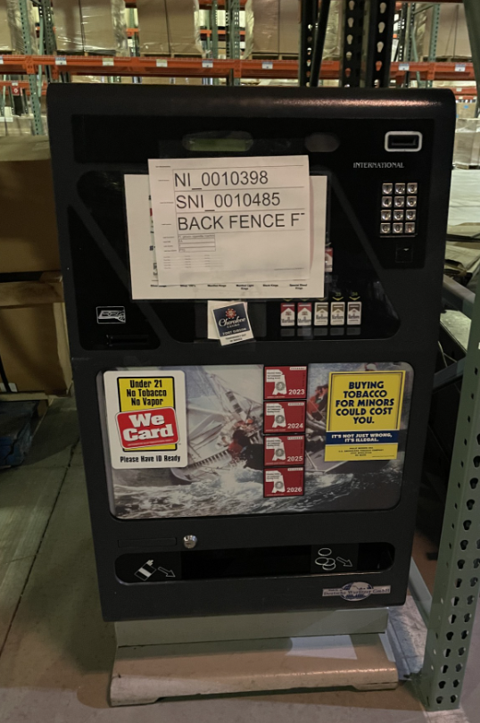
- Model # 67132
- Ser # 440561554
- 28’ Wide X 19” Deep X 54” Tall
- QTY: 1
- Price for Sell: 1700.00

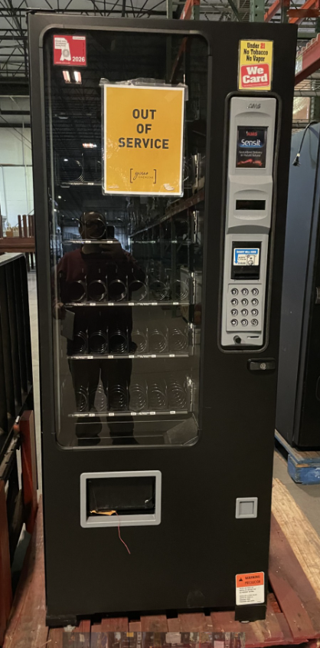

- Model # 8636
- Ser # 1-2308-5624
- 29’’ Wide X 29” Deep X 72” Tall
- Price for sell: 2000.00

- Model # 3507
- Ser # 123168608283
- 29” Wide X 29” Deep X 72” Tall
- Price for sell: 2000.00
- QTY 2
- Model # 3506
- Ser # 123653209152
- 21” Wide X 35” Deep X 69”Tall

- Model # 3506
- Ser # 123653009152
- 21” Wide X 35” Deep X 69” Tall

- Model # 3582
- Ser # 136600214288
- 21” Wide X 35” Deep X 72” Tall

- Model # 3582
- Ser # 14177621678
- 21” wide X 35” deep X 72” Tall
- Price for Sell: 2000.00
- QTY 4
