Statement of Work
Date | 6/17/2026
Client | Cherokee Nation Entertainment (CNE)
Job Name | Machine Entry Authorization Log (Meal Books)
Requested by | Carla Davies
Summary
Cherokee Nation Entertainment is requesting bids for Machine Entry Authorization Logs. Must be licensed through the Cherokee Nation Gaming Commission CNGC and the Oklahoma Horse Racing Commission OHRC. Books will be printed double-sided, 1 color with 92 pages including the cover. Books must be scored, folded, collated and saddle stitched.
Project Scope
The winning bidder is expected to provide

Components:

Vendor Provided
- 9,680 complete meal books with the below specifications.
- Books must be in hands by August 15, 2026

Key Requirements
- Gaming Meal Books
- 5.5” X 8.5”
- 92 pages including cover
- Cover : 80# white gloss
- Inside: 50# offset white
- Score cover – fold – collate – saddle stitch
- Prints double sided – 1 color black
- See attached pictures
- 80 per case

Statement of Deliverables

Please provide shipping costs for delivery to the below locations. Once we review shipping we will determine if one bulk shipment is needed or if we will be shipping to all locations.

Examples: Front Cover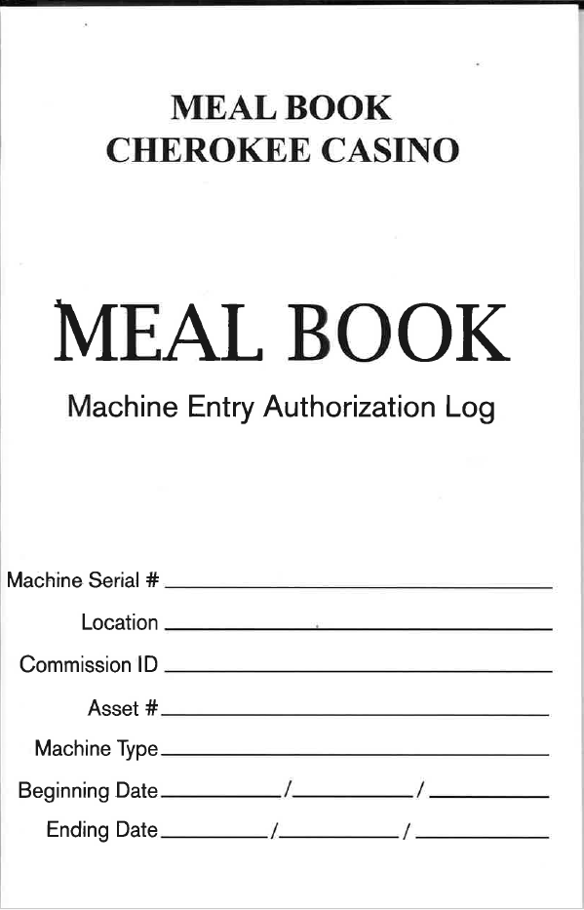

Inside
