Money Machine Deluxe Hard-case Cash Cube DESIGNED FOR PORTABILITY AND FUNCTIONALITY. Money Machine Hard Case - Money Machine. The money machine includes proprietary technology that keeps the money circulating and prevents "piling up". Our Hard Case money machine is the ultimate in convenience, durability, and ease of use. * New Metal And TUFFBILT Poly-Carbonate Construction * New Removable Dolly for Easy Transport and 360-Degree Visibility * New Colored LED lights with Wireless Remote * New Digital Countdown Timer with Wireless

* High Gloss Metallic Paint Finish
* Metal And TUFFBILT No-Scratch Poly-Carbonate
Construction
* Built In Dolly for easy transport
* Industrial Grade Blower with 3-year warrantee
* Shock Resistant Interior With Reflective Back
Panel
* Flashing Chaser Lights
* 290 bills in play money
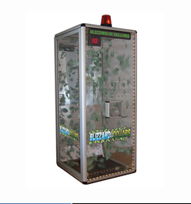
Weight: 195 lbs w/o blower
Size: 37 1/2" x 37 1/2" x 78 (36")
or you can choose:
Size 33 1/2" X 33 1/2" X 78" (32"

See Picture for Reference!

