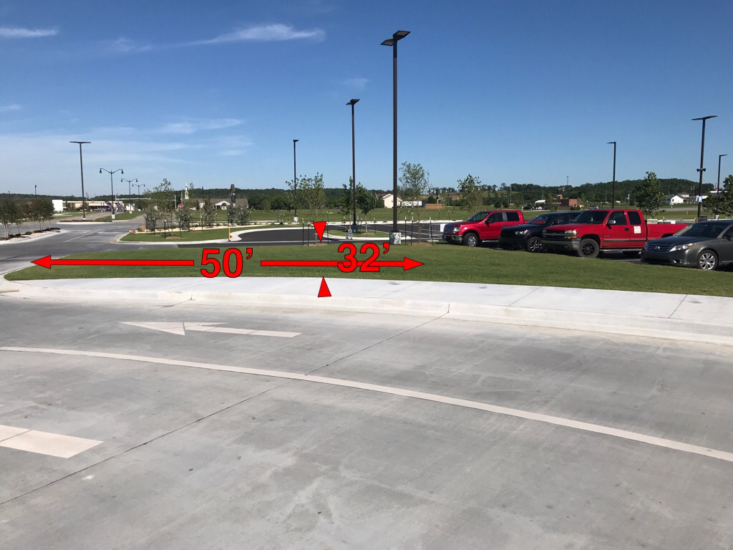
The 50’ measurement is from the curb to the tree in front of the red Ford truck.
The 32’ is from the second tree, up three-fourths of the way to the curb.
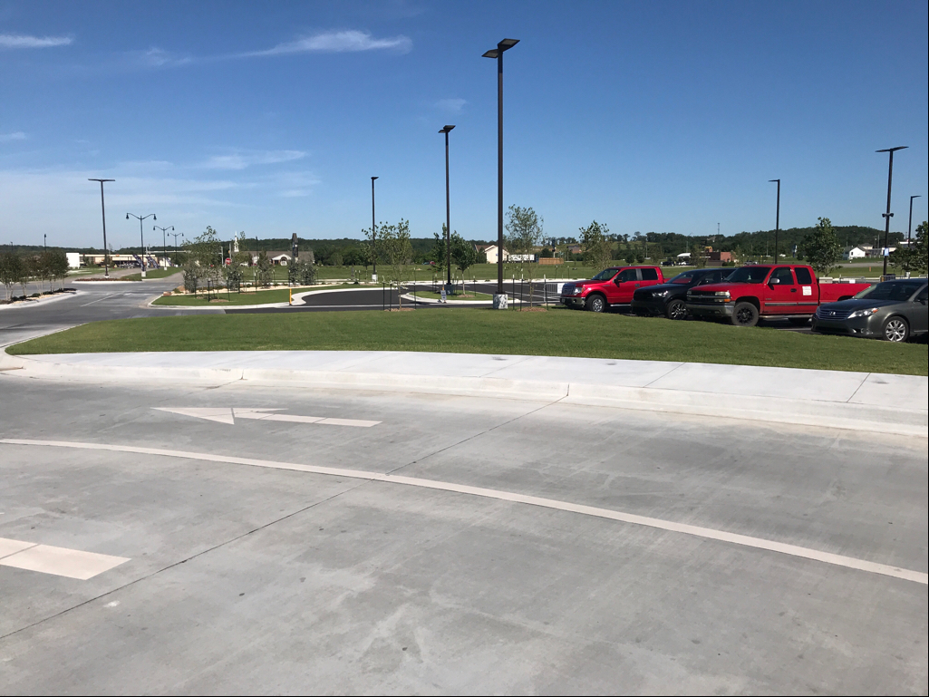
Cherokee Casino Tahlequah main entryway with a Porte-cochere and flag poles.

