Request for Proposal
Public Art Installations
CULTURAL DEVELOPMENT CENTER – Vinita, OK

Summary
Cherokee Nation Businesses (CNB) is accepting proposals for multiple artwork installations for permanent display at the Cultural Development Center in Vinita, Oklahoma. Art proposal to be produced by an individual Cherokee Nation artist or by a team (2 or more) of Cherokee Nation artists to create mixed media art installations to enhance the interior and exterior of the property.

LA 25-05 requires all Cherokee Nation construction and/or renovation projects $500,000+ to set aside 1% of the total project cost for the procurement of culturally appropriate art. The use of these funds allows the Cherokee Nation to share our rich history, culture and heritage through visual art.

CNB only accepts bids from Cherokee Nation citizens who can provide identification as such and artists previously designated as Cherokee National Treasures.

Description
Opportunities for several art installations in various spaces throughout the property. Artists can bid on one or more elements of the project. Individual artist or team will be responsible for concept, production and installation of work.

Interior spaces and details of commissioned art are as follows:
- Custom sinks for public restrooms – total of 5 sinks, examples of materials include but are not limited to: ceramic or stone.
  - Dimensions of sinks for restrooms: VESSEL SINKS SHOULD BE APPROXIMATELY 22" L x 15" W x 7" H. ALL VESSEL SINKS WILL BE SEMI-RECESSED INTO THE VANITY TOP IN ORDER TO MEET ADA COMPLIANCE. ARTIST TO SUBMIT VESSEL SINK DESIGN TO ARCHITECT FOR SIZE AND MATERIAL APPROVAL PRIOR TO FABRICATION.
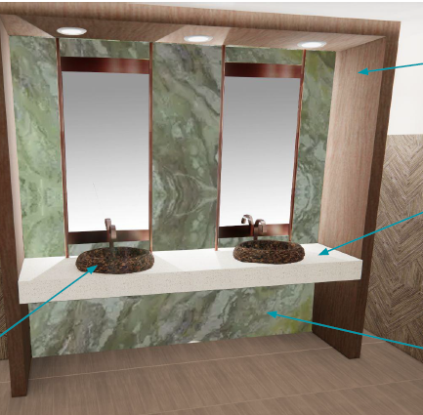
- Basket weave wall behind the coffee bar – examples of materials include but are not limited to: PVC, metal, wood, or reed.
  - Dimensions for basket weave wall: APPROXIMATELY 6'-0" OVERALL HEIGHT ABOVE FINISHED COUNTERTOP AND APPROXIMATELY 15'-0" OVERALL WIDTH. THE WIDTH OF EACH BASKETWEAVE FEATURE PIECE IS APPROXIMATELY 0'-6" WIDE AND APPROXIMATELY 2" THICK. (DETAILS OF MOUNTING METHOD, FASTENING MECHANISMS REQUIRED, AND MATERIALITY TO BE FINALIZED UPON BID AWARD). PIECES ARE DESIGNED TO FIT WITHIN DESIGNATED LOCATIONS. THE ARTIST SHALL BE RESPONSIBLE FOR SIZING THE INSTALLATION ACCORDINGLY AND SUBMIT FINAL DESIGN TO ARCHITECT AND CLIENT PRIOR TO PRODUCTION. RENDERINGS SHOWN/ATTACHED ARE FOR DESIGN INTENT ONLY.
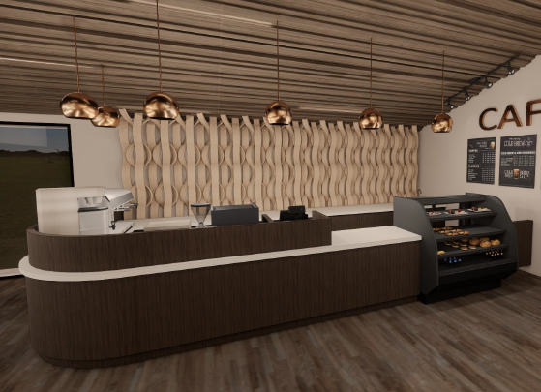
- Basket weave wall between the reception desk and the coffee bar – examples of materials include but are not limited to: PVC, metal, wood, or reed.
  - Dimensions for basket weave wall: APPROXIMATELY 14'-0" OVERALL HEIGHT ABOVE FINISHED FLOOR AND APPROXIMATELY (QUANTITY OF 2) 5'-0" WIDE IN A 15'-5" OVERALL WIDTH. THE WIDTH OF EACH BASKETWEAVE FEATURE PIECE IS APPROXIMATELY 0'-6" WIDE AND APPROXIMATELY 2" THICK. (DETAILS OF MOUNTING METHOD, FASTENING MECHANISMS REQUIRED, AND MATERIALITY TO BE FINALIZED UPON BID AWARD). PIECES ARE DESIGNED TO FIT WITHIN DESIGNATED LOCATIONS. THE ARTIST SHALL BE RESPONSIBLE FOR SIZING THE INSTALLATION ACCORDINGLY AND SUBMIT FINAL DESIGN TO ARCHITECT AND CLIENT PRIOR TO PRODUCTION. RENDERINGS SHOWN/ATTACHED ARE FOR DESIGN INTENT ONLY.
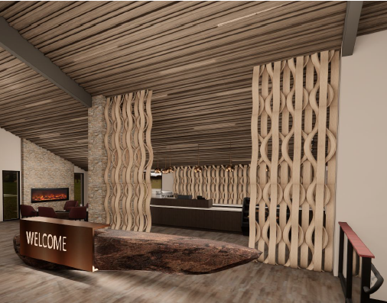
- Reception desk chandelier feature – examples of materials include but are not limited to: metalwork, glasswork, or clay/ceramics.
  - Dimensions for chandelier: OVERALL APPROXIMATE HEIGHT OF FIXTURE, INCLUDING ROD OR CABLE, TO BE 8'-6". ARTIST TO COORDINATE INSTALLATION METHOD, ELECTRICAL REQUIREMENTS, OVERALL WEIGHT, MATERIALS, AND INTENDED USE OF FIXTURE WITH ARCHITECT AND OWNER. IF LIGHTING IS INCORPORATED INTO THE ART INSTALLATION, UL LISTING COMPLIANCE IS REQUIRED.

Exterior spaces and details of commissioned art are as follows:
- Outdoor feature at reflecting pool – For this area, it is suggested that there be a pottery element to the water feature.
  - Dimensions for pool: POOL IS 10’ DIAMETER.
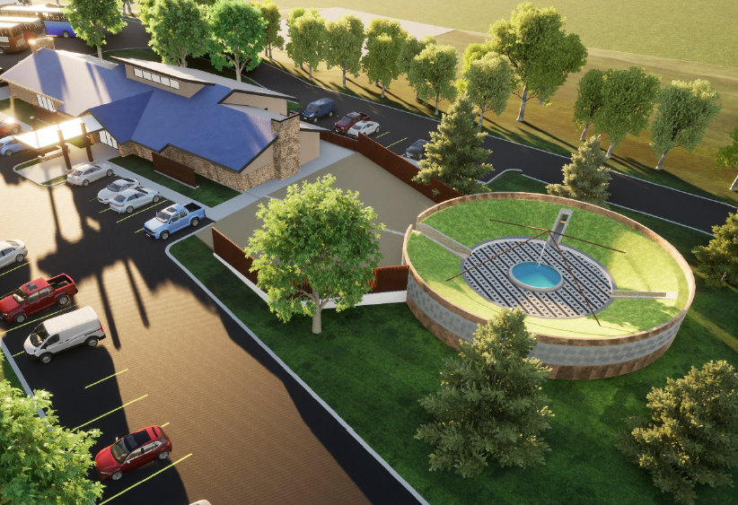
- Outdoor fence feature – “screen wall” along north side of building
  - SCREEN WALL, INCLUDING GATE – TOTAL OF 87’9” LINEAR FEET. APPROXIMATE HEIGHT IS 6’6”.
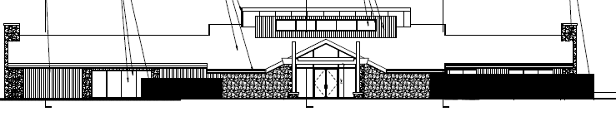

Proposal Overview
Project Proposal should include:
- Conceptual rendering of proposed installation, including proposed mediums with proposed dimensions
- General approach to project
- Proposed project schedule with key milestones, including installation timeline
  - Artist(s) may submit bid as a phased approach if providing details of what will be completed during each phase.
- If proposing as a team of 2 or more artists, the following must be included:
  - A project lead as the general contractor and a list of other artists as subcontractors
  - Cherokee Nation Businesses will hold contract with the project lead, who will work directly with Cherokee Nation Cultural Tourism staff to coordinate artwork and installation
  - All team members must be citizens of the Cherokee Nation or previously designated Cherokee National Treasures
- Projected cost estimate with a breakdown of associated costs such as labor, materials and artist fees (broken down per artist, if applicable)
- Artwork will apply to all safety standards and structural requirements

Proof of Citizenship
Cherokee Nation law requires the purchase of art from Cherokee Nation citizens only. You must submit a copy of your Blue Card or Citizenship Card when submitting an initial sketch. No exceptions.

Proposal Review
Proposals will be reviewed based on overall concept, expertise of project team, potential for total project execution, and price.

Bid Information
There will be a mandatory pre-bid meeting on Thursday, May 20, 2021, at 10:00 am at 945 E. Illinois Ave., Vinita, OK 74301. Masks are required on site.
Deadline to submit proposals is 4:00 pm on Thursday, June 3, 2021 to: Charla Boroughs, CNE Buyer. Designs can be digitally submitted by email to charla.boroughs@cnent.com.
If you would like to drop off your submissions in Tahlequah, please submit to Keli Gonzales, Cultural Art Coordinator, at 950 Main Parkway in Tahlequah, OK 74464.

Selections will tentatively be made by 5:00 pm on Tuesday, June 15, 2021. Artists will be notified shortly thereafter.

