Cherokee Nation Businesses, LLC, (CNB), a wholly owned tribal company of the Cherokee Nation is seeking qualified bids for Affirmative Action Plan Outsourcing. The selected vendor will be responsible for the creation, submission, and support the multiple Affirmative Action Plans, EEO-1, Vets-4212, and California Pay reporting. The vendor must be able to accept employment data from multiple and disparate systems and possess cutting edge data tools that can scrub and correct errors in the data to ensure accurate reporting. The vendor must have deep expertise in affirmative action regulatory requirements of the OFCCP and must provide audit support and expert consultation. The vendor will also provide a robust training program for best practices on compliance reporting, data management.

Requirements include:
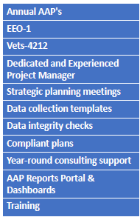

Proposals are to be emailed to the buyer, Charla Boroughs, at charla.boroughs@cnent.com, by February 2, 2022 at 3:00 PM CST. If you have any questions, contact the buyer at the above email.

