Graphic Design RFP

Suite Tower at the Hard Rock Hotel & Casino Tulsa

Cherokee Nation Entertainment

Catoosa, Oklahoma

Part 1: Elevator Landing Wall Mural – 4 unique artist images acquired from Getty Images to be digitally manipulated as shown below for inspiration. All 4 images should follow same graphic color scheme but will be different artist. Getty Images will be acquired by CNE and provided to the graphic artist.
Level 5, 6, 8 & 9
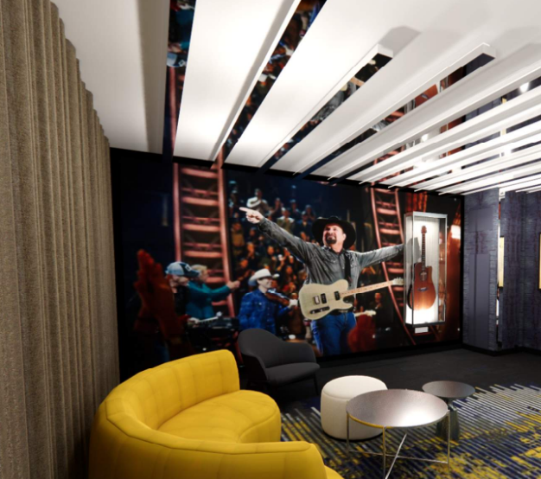

Part 2: Elevator Landing Wall Art – 3 unique artist images acquired from Getty Images to be digitally manipulated as shown below for inspiration. All 3 images should follow same graphic color scheme but will be different artist. Getty Images will be acquired by CNE and provided to the graphic artist.
Level 4, 7 & 10

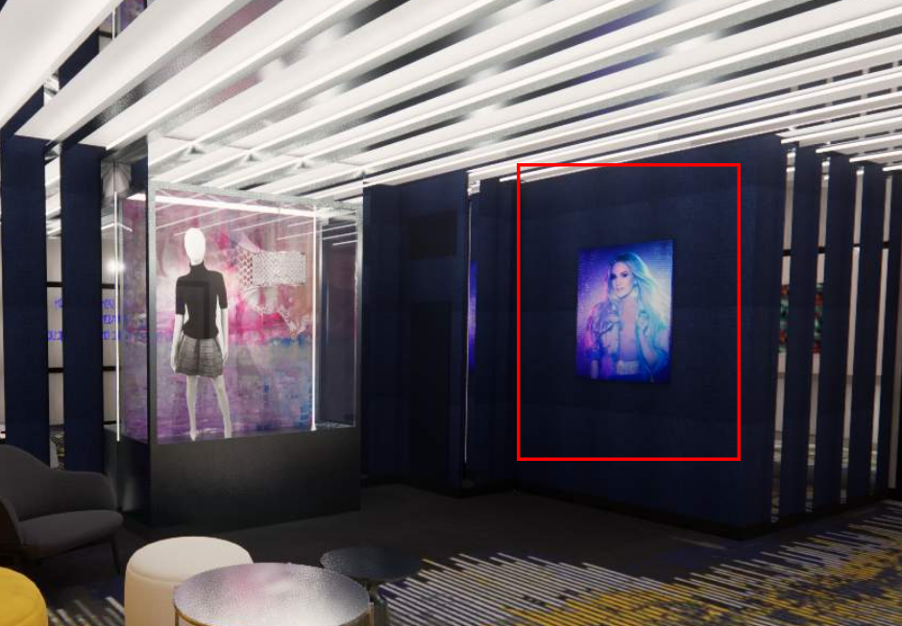

Part 3: Corridor Art – 35 unique artist images acquired from Getty Images to be digitally manipulated as triptych art set, shown below for inspiration; 5 images per floor. Center graphic to be an artist image, flanked by two graphics utilizing unique pattern. All 35 images should follow same graphic color scheme but will be different artist. Getty Images will be acquired by CNE and provided to the graphic artist.
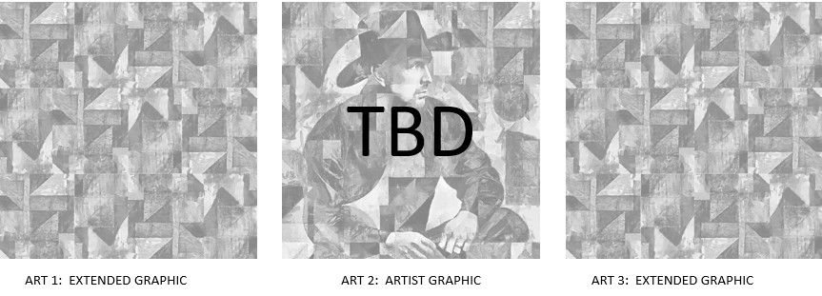

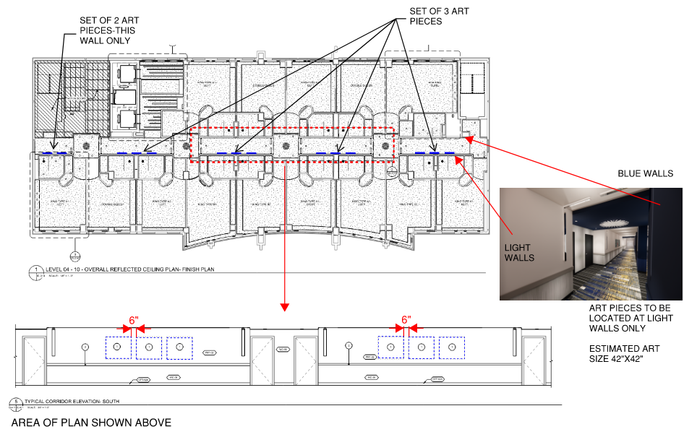

Part 5: Guestroom Artwork - 6 unique artist images acquired from Getty Images to be digitally manipulated as an artwork, shown below for inspiration; 1 image per room type based on graphic shown below. All 6 images should follow same graphic color scheme but will be different artist. Getty Images will be acquired by CNE and provided to the graphic artist

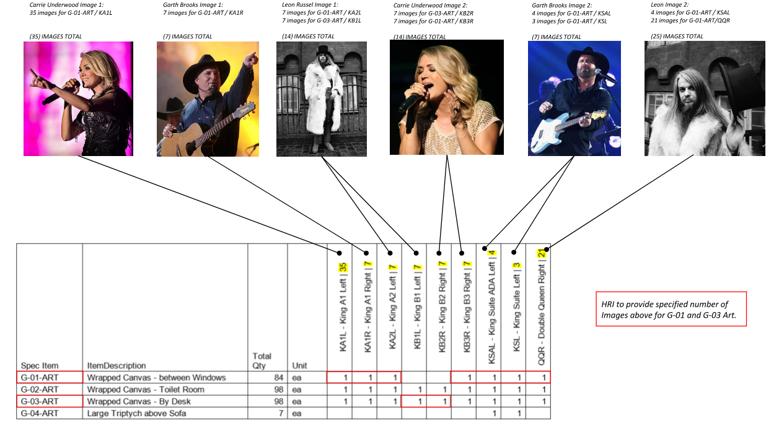
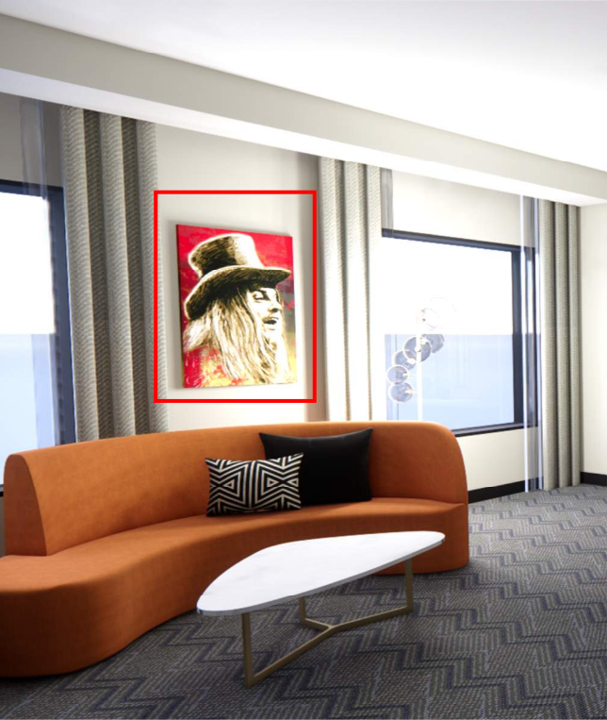
Part 6: Guestroom Branded Artwork - 3 unique images acquired by Graphic Designer to be digitally manipulated as an artwork, shown below for inspiration; 2 images per room type based on graphic shown below. All 3 images should follow same graphic color scheme but will be different theme. Branded images to be selected by Graphic Designer.

