Request for Art Proposals
Public Art Installation
TRAIL OF TEARS MEMORIAL – Tahlequah, OK

Summary
Cherokee Nation Businesses (CNB) is accepting proposals for an artwork installation for long-term display on the grounds of the Cherokee National History Museum, Oklahoma. Art installation to be produced by an individual Cherokee Nation artist or by a team (2 or more) of Cherokee Nation artists to create mixed media art installations to enhance the exterior of the property.

LA 25-05 requires all Cherokee Nation construction and/or renovation projects $500,000+ to set aside 1% of the total project cost for the procurement of culturally appropriate art. The use of these funds allows the Cherokee Nation to share our rich history, culture and heritage through visual art.

CNB only accepts bids from Cherokee Nation citizens who can provide identification as such or artists previously designated as Cherokee National Treasures.

Description
The Cherokee National Capitol square is currently undergoing a master site planning process to enhance the community and visitor experience in downtown Tahlequah, OK. The current master site plan hopes to improve pedestrian access around the Cherokee National History Museum, create additional outdoor program and event space, enhance the existing landscape and create a Trail of Tears Memorial on the south side of the property.

In order to appropriately honor the history and culture of the Cherokee people, proposals are being accepted from Cherokee Nation artists to interpret the Cherokee Removal story through an outdoor permanent art installation. The current master plan concepts for the memorial call for 32’ diameter reflecting pool and extensive landscape features. Artists can propose works that would best help memorialize and share this story.

Conceptual renderings (subject to change with bid selection):
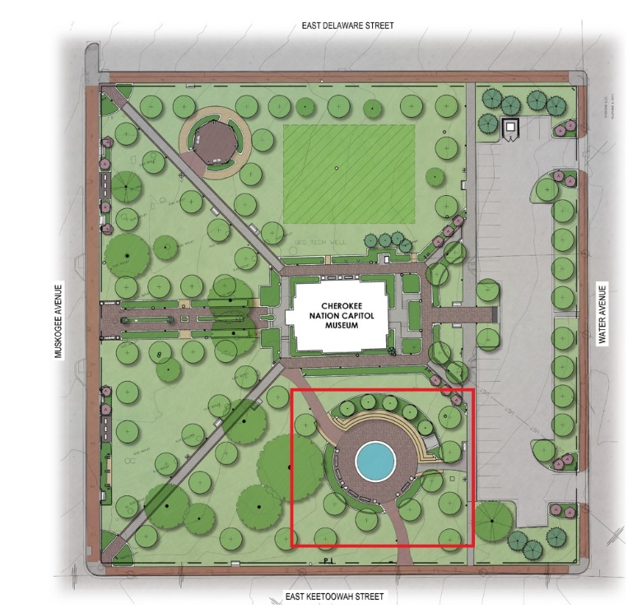
Location on square.

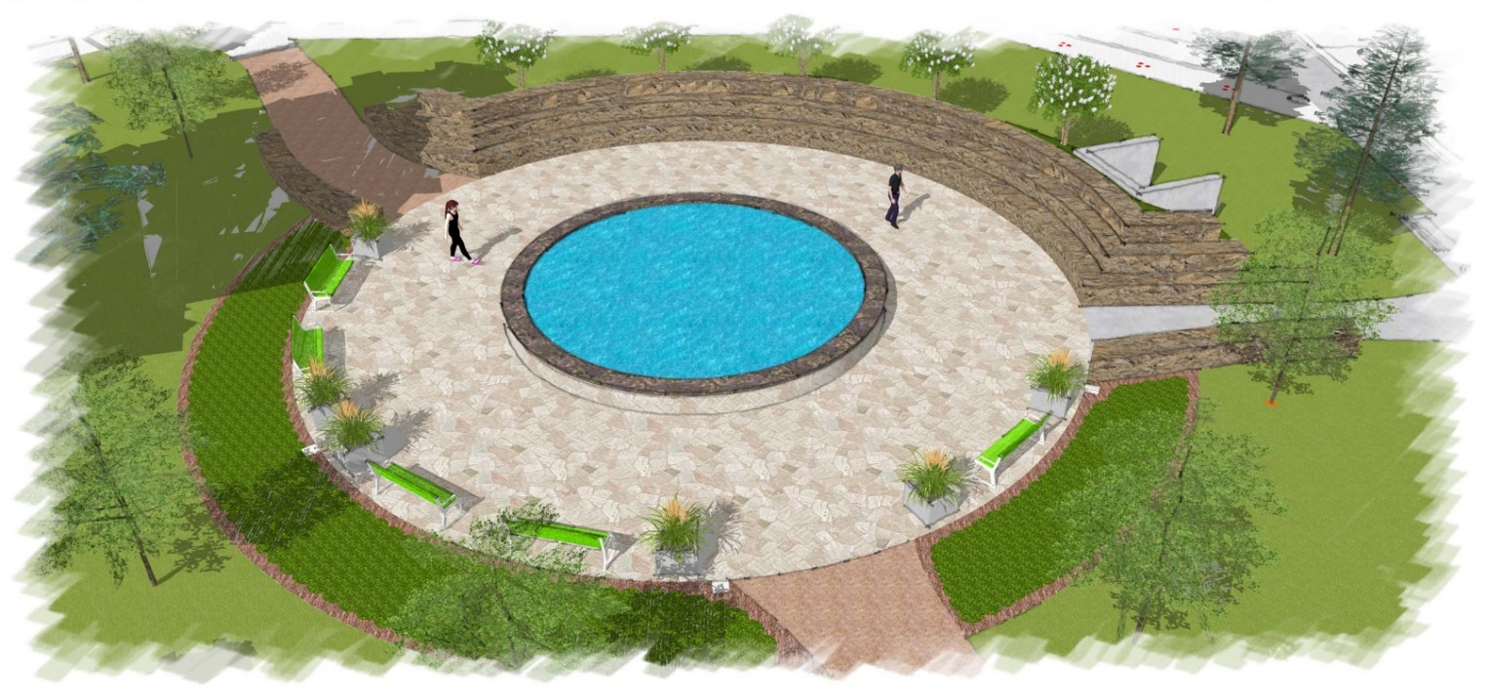
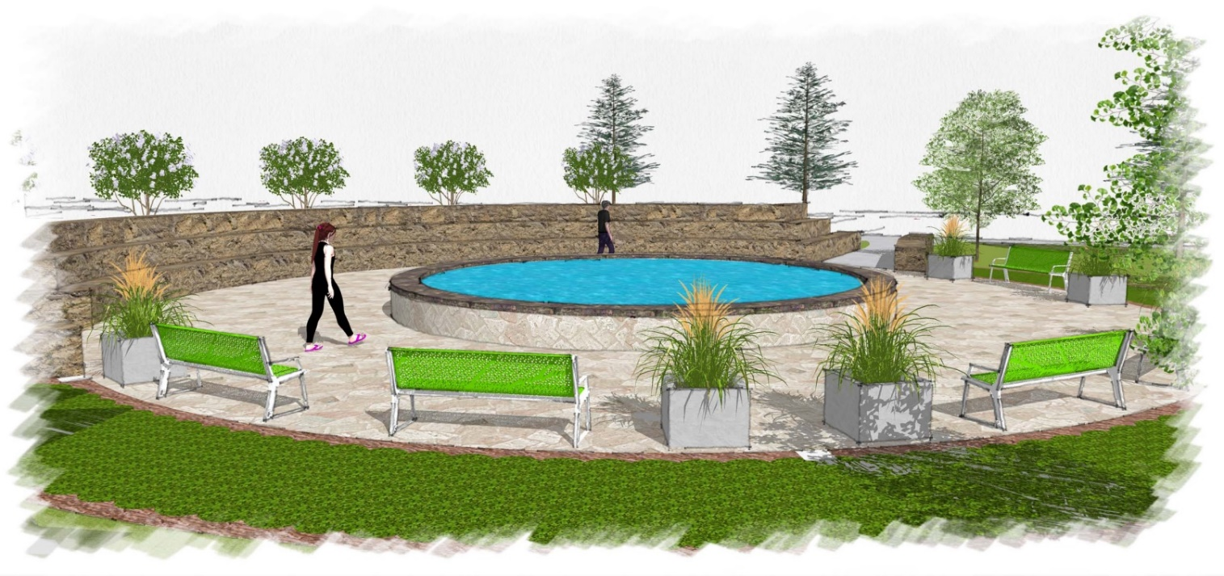
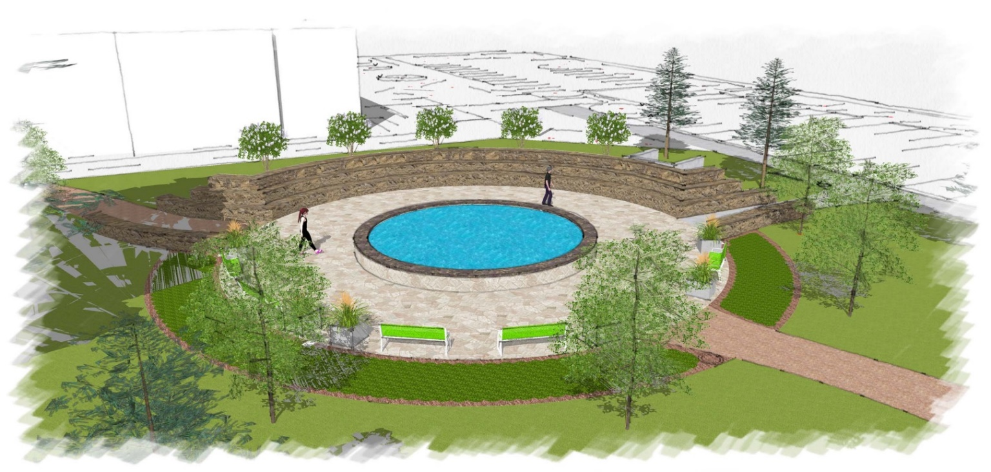
Proposal Overview
Project Proposal should include:
- Conceptual rendering of proposed installation, including proposed mediums with proposed dimensions
- General approach to project
- Narrative of theming and interpretation
- Proposed project schedule with key milestones, including installation timeline
  - Artist(s) may submit bid as a phased approach if providing details of what will be completed during each phase.
- If proposing as a team of 2 or more artists, the following must be included:
  - A project lead as the general contractor and a list of other artists as subcontractors
  - Cherokee Nation Businesses will hold contract with the project lead, who will work directly with Cherokee Nation Cultural Tourism staff to coordinate artwork and installation
  - All team members must be citizens of the Cherokee Nation or previously designated Cherokee National Treasures
- Projected cost estimate with a breakdown of associated costs such as labor, materials and artist fees (broken down per artist, if applicable)
- Artwork will apply to all safety standards and structural requirements

Proof of Citizenship
Cherokee Nation law requires the purchase of art from Cherokee Nation citizens or previously designated Cherokee National Treasures only. You must submit a copy of your Blue Card, Citizenship Card or proof of Cherokee National Treasure status when submitting a bid. No exceptions.

Proposal Review
Proposals will be reviewed based on overall concept, expertise of project team, potential for total project execution, and price.

Bid Information
There will be a mandatory onsite pre-bid meeting at 10:00 AM on Thursday, March 9, 2023 at 101 S. Muskogee Ave., Tahlequah, OK 74464.
Deadline to submit proposals is 4:00 pm on Thursday, April 20, 2023 to: Charla Boroughs, CNE Buyer, at 1102 No. 193rd E. Ave, Building 3; Catoosa, OK 74015.
If you would like to drop off your submissions in Tahlequah, please submit to Dala Kelley or Devin Dry at 3377 Cherokee Springs Rd., Tahlequah, OK 74464.

Designs can also be digitally submitted, by the deadline, by emailing those to Charla.Boroughs@cnent.com.

