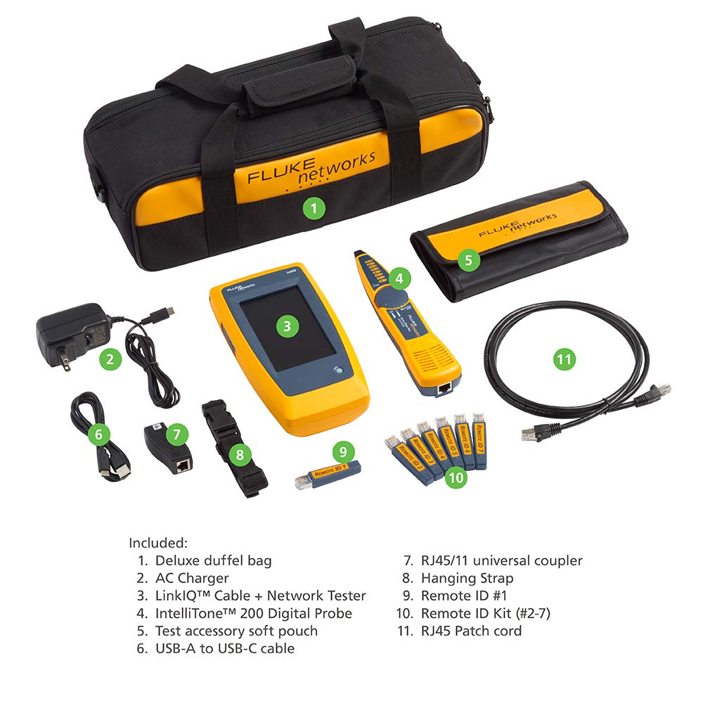

- Cable Performance testing up to 10GBASE-T via frequency-based measurements
- Network features including: IPv4 and v6 ping, nearest switch diagnostics (IP address, name, port / VLAN number, and advertised data rates).
- Ethernet Alliance certified PoE Verification – Detects the PoE class (1-8) and power, and performs a load test of available PoE from the connected switch
- Displays cable length, wire map, and distance to open or short
- Manage results and print reports from LinkWare PC
- Includes IntelliTone Probe to assist in locating cables

